Name: | Abdulrahman Khalid Al-Muzaini
ID: | 441004887
Instructor: | Murtaza Ali Khan

Brief description of the classes:
This project uses 5 classes:
The first is the driver class FinalProject which has the main method, the main method makes an instance of the Settings class and the SettingsFrame class.
The second class is the Settings class: this class store the current settings to pass to the panel, it has 10 class variables which are settings that will be later passed on to the panel, and two constructors, one which is the default constructor that initializes the default values for the settings, the second one is a constructor that will be used to update the settings.
this class also has getter methods for each variable, and a printSettings method that prints the current value for the class variables.
The third class is the SettingsFrame class: this class makes the User Interface (UI), it is used to customize and choose which animation to run, change the settings for curve, and change the animation frame size among many features, it updates the Settings class with the values the User has chosen.
The fourth class is the AnimationOf2DRectangles class: this class is the frame that we will add our panel to.
The fifth class is the A2DRPanel class: this is the panel that will draw our animation in, it uses the values in the Settings class and passes them to its various methods to run the correct animation.

Screenshots from the project

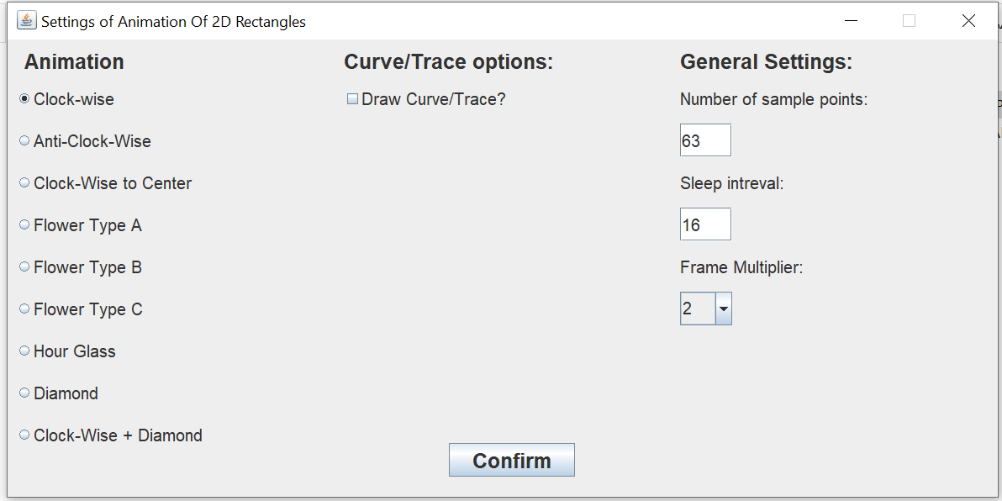
(fig 1A) What the SettingsFrame looks like when the program starts with the default Settings.

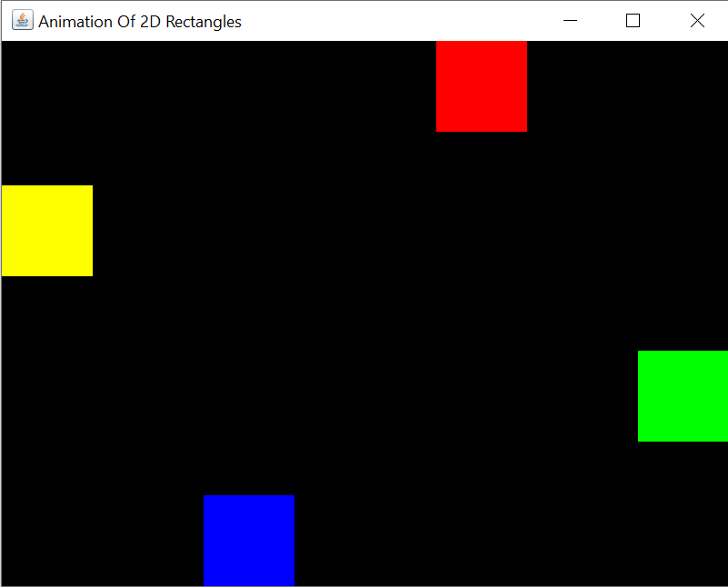
(fig 1B) The default animation and settings

Detailed description
of each class and it’s methods
1- Settings Class:
The Settings class stores the settings that will be passed to the animation frame and panel classes as class variables.
this class has 10 class variables which are:
(int) nRecSetting: it stores an integer value which corresponds with the number of rectangles that we will use.
(Note: In all the animations of this project, the number of curves equals the number of rectangles.)
(int) animationSetting: it stores an integer value which corresponds with the index of the animation to use.
(boolean) drawCurveSetting: it stores a boolean value which determines weather to draw the curve or not.
(String) curveClrSetting: it stores a string value which determines which color the curve will be drawn in.
(Note: if drawCurveSetting is false this setting effect won’t be visible.)
(String) traceOptSetting: it stores a string value that determines whether to draw all curves or just one.
(Note: if drawCurveSetting is false this setting effect won’t be visible.)
(int) curveToTrace: it stores an integer value which corresponds to the curve that will be drawn.
(Note: if drawCurveSetting is false and if traceOptSetting doesn’t equal “One Curve” this setting effect won’t be visible.)
(int) nSetting: it stores an integer value which corresponds to the number of sample points used to make the curves.
(int) sleepSetting: it stores an integer value which corresponds to the time interval between each movment in milli seconds
(String[]) recsClrSetting:it stores an array of strings, it contains the values for the colors used for the rectangles, indexes 0-3 store the string values corresponding to the four rectangles used for most animations, the indexes 4-7 store the string values corresponding to the four extra rectangles used in the last animation (Clock-Wise + Diamond).
(Note that in this project, this setting is never changed, in order to change the color of the rectangles the user has to change the code in the default constructor.)
(int) frameMultSetting: it stores the Multiplier for the animation frame size.
(Note that the default frame size is 400 for width and 300 for height, this setting multiplies this size by the value of this setting, some devices might need to use either 1 or 2 because their display screen is small.)
This class also has two constructors, one that sets up the default values when this project is run, the second is called in the SettingsFrame class to update the Settings class.
This class also has the method printSettings() to print the values stored in this class.
2- SettingsFrame Class:
This class is the User Interface (Graphical User Interface GUI) for this project.
It’s a frame that implements an ActionListener and a MouseMotionListener.
The ActionListener is used to choose the settings with the various radio buttons,
check boxes, combo boxes, and text fields.
The MouseMotionListener is used to detect if the Curser is near the text fields to allow editing them.
This frame is sectioned to three categories: Animation, Curve/Trace Options, and General settings.
In the Animation section, the user selects which animation to run, the default choice is the Clock-Wise animation, which was the original goal for this project.
Each animation changes the output that the user will get to the selected animation.
In the Curve/Trace Options section, the user chooses weather to draw the curve/trace (tracing is when we’re choosing to only draw one curve and follow the rectangle that was on that curve)
if the user checks the checkbox to draw the curve more options will appear, one is to choose the color of the curve, the second is to choose weather to draw all the curves or just one.
if the user chooses to draw only one curve another option will appear to choose which curve to trace.
In the General Settings section, the user chooses the number of sample points the curves will have, the sleep interval, and the frame multiplier.
(Note that the number of sample points is in the general settings section because it’s also controls the number of movements, which changes how the “fast” the rectangles move, for example, if the user enters 600 number of sample points and the sleep interval is set to 1, then tried again with 900 number of sample points with the same sleep interval, the rectangles will look to move slower)
The frame multiplier chooses the multiplier for the animation frame, 1 is the smallest setting and 4 is the largest setting.

One of the features of this class is that it detects if the user attempts to enter a non-integer value in the Number of sample points text field (nField) and throws an error message alerting the user to enter only integers!

After the user is satisfied with their settings, hitting the confirm button will create an instance of the AnimationOf2DRectangles class, which is the animation frame, then that frame will make the panel.

3- AnimationOf2DRectangles and A2DRPanel Classes:
The AnimationOf2DRectangles class is the frame of the animation.
Its width is set to 400 multiplied by the frameMultSetting.
Its height is set to 300 multiplied by the frameMultSetting.
The frame then adds the A2DRPanel.

The A2DRPanel class is the panel of the animation.
this class is where the animation is drawn in.
Here are the variables in this class and their meaning/use:
Type | Variable | Meaning/Use
int | PW | Panel Width.
int | PH | Panel Height.
int | RW | Rectangle Width.
int | RH | Rectangle Height.
int | nRec | number of rectangles.
Rectangle2D.Double[] | recs | array containing the rectangle objects that will be drawn.
Color[] | recClr | a color array to store the colors of the rectangles.
String[] | clrs | a string array containing the String representation of the rectangles colors.
int[][] | cords | a multi-dimensional array containing the coordinates of the rectangle objects  cords[rectangle][axis]
Point | P0 | Top Left Point
Point | P1 | Top Right Point
Point | P2 | Bottom Right Point
Point | P3 | Bottom Left Point
Point | PC | Center Point
Point | Pup | Center Top Point
Point | Pdown | Center Bottom Point
Point | Pleft | Center Left Point
Point | Pright | Center Right Point
int | N | Number of sample points
int | sleep | sleep interval
int | index | used to access and store the current index of Pt
int[] | loc | an array used to hold on which curve the rec is at  loc[curve]
int[][][] | Pt | a multi-dimensional array used to store the values of the Bezier curve  Pt[curve][axis][value]
String | traceOpt | a string used to choose weather to draw the curve or not and if drawn weather to draw all the curves or just one
int | recToTrace | used to choose which rectangle/curve to trace if traceOpt == “One Curve”
Color | traceClr | the color of the curve drawn if curves were drawn
Thread | thrd | thread

The panel starts with initializing the points and spawning the rectangles with the methods createPoints() and spawnRecs(), then initializes the animation with the method animation() onto which the AnimationSetting from the Settings class will be passed
The heart of this project is the Bezier Curve, here the General definition was used:
$$B\left(t\right)=\sum_{i=0}^{n}{\left({n \atop i}\right){\left(1-t\right)}^{n-i}t^{i}P_{i}}$$
This expression needs the binomial coefficients and factorial to be implemented, which are implemented by the methods bicoef(int k, int n) and factorial(int n)

The check() method check to see if the rectangle is at the start of a curve and stores it’s location (on which curve it’s at) to the loc variable.
The move() method stores the value of the curves in the current index to the rectangle cords array.

Known Implementation issues:
One of the issues is that the frames use fixed sizes which might not work properly for some devices with smaller display screens.

